WATERPROOF LED POWER SUPPLY
INSTALLATION GUIDE
Model | Input Voltage | Input Current | PF | Output Voltage | Power (max) | Protections | Dimension (mm) | Price list
 |  |  |  |  |  |  | （L×W×H） | (USD)
LPH12-025 | AC 100-240V 50/60Hz | 0.34A | 0.9 | DC12V | 25W | Short circuit Protections、  overload Protections、  over volatge Protections | 160×49.5×32.5 | $15
LPH12-060 | AC 100-240V 50/60Hz | 0.83A | 0.9 | DC12V | 60W |  | 245×49.5×32.5 | $21.8
LPH12-100 | AC 100-240V 50/60Hz | 1.34A | 0.9 | DC12V | 100W |  | 245×49.5×32.5 | $24
LPH24-025 | AC 100-240V 50/60Hz | 0.34A | 0.9 | DC24V | 25W |  | 160×49.5×32.5 | $15
LPH24-060 | AC 100-240V 50/60Hz | 0.83A | 0.9 | DC24V | 60W |  | 245×49.5×32.5 | $21.8
LPH24-100 | AC 100-240V 50/60Hz | 1.34A | 0.9 | DC24V | 100W |  | 245×49.5×32.5 | $24
A．Specifications：

B．Features：
- Protections: short circuit protection, overload protection, over volatge protection；
- Universal AC input/Full range/High power factor；
3. Power supplies can be used in dry, damp and wet locations;
4. Suitable for LED lighting and moving sign applications.
C．Installing the power supply：
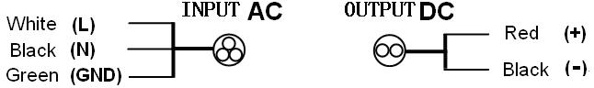
installation diagrams
- Insure the input and output service wires are connected properly and are not reversed.
- The waterproof LED power supply should have a good ground.
- Securely mount the power supply on the metallic surface, free airflow should be ensured to provide adequate ventilation.
- Service and/or installation should only be performed by qualified personnel.

Separate collection for electrical and electronic equipment.

